14.79: If the block were uniform, the buoyant force would be along a line directed through its geometric center, and the fact that the center of gravity is not at the geometric center does not affect the buoyant force. This means that the torque about the geometric center is due to the offset of the center of gravity, and is equal to the product of the block’s weight and the horizontal displacement of the center of gravity from the geometric center, 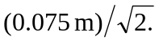 The block’s mass is half of its volume times the density of water, so the net torque is

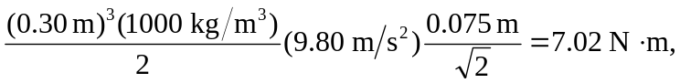

or 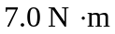to two figures. Note that the buoyant force and the block’s weight form a couple, and the torque is the same about any axis.

